AAYUSH PATIL - 56

MLDL EXPERIMENT 9

AIM -
Implement Recurrent Neural Network (RNN) / LSTM for time series or text data

DATASET SOURCE -

https://archive.ics.uci.edu/dataset/360/air+quality\

DATASET DESCRIPTION -

The dataset used in this experiment is the Air Quality Dataset obtained from the UCI Machine Learning Repository. It contains hourly averaged responses from an array of chemical sensors deployed in an Italian city to monitor air pollution levels.
The dataset includes several attributes related to air quality measurements such as concentrations of gases and sensor responses. For this experiment, only the CO(GT) attribute is used, which represents the concentration of Carbon Monoxide in the air.
The dataset contains missing values represented by -200. These values are replaced with NaN (Not a Number) and removed during preprocessing to ensure data quality. The dataset is then normalized before being used for training the model.

THEORY

1. Time Series Data
Time series data consists of observations recorded sequentially over time. The order of observations is important, as each data point depends on previous values. Unlike traditional datasets where samples are independent, time series data exhibits temporal dependency.
Examples include stock prices, weather data, and pollution levels. In this experiment, the CO concentration values are treated as a time series.

2. Recurrent Neural Networks (RNN)
Recurrent Neural Networks are a class of neural networks designed to process sequential data. They maintain a hidden state that captures information from previous inputs, enabling the network to have memory.
However, standard RNNs suffer from the vanishing gradient problem, which makes it difficult for them to learn long-term dependencies in sequences. As a result, their performance degrades when dealing with long sequences.

3. Long Short-Term Memory (LSTM)
LSTM is an advanced type of RNN designed to overcome the limitations of traditional RNNs. It introduces a memory cell and gating mechanisms that regulate the flow of information.
An LSTM unit consists of three main gates:
- Forget Gate: Determines which information from the previous state should be discarded
- Input Gate: Decides which new information should be stored in the memory
- Output Gate: Controls the output based on the current memory state
These gates enable the LSTM to retain important information over long periods and discard irrelevant data, making it suitable for time-series prediction tasks.

4. Data Preprocessing
The dataset undergoes several preprocessing steps before training:
- Selection of the CO(GT) column as the target variable
- Replacement of missing values (-200) with NaN and removal of such rows
- Normalization of data using MinMaxScaler to bring values between 0 and 1
Normalization helps improve the convergence of the neural network during training.

5. Sequence Generation
Since LSTM requires sequential input, the dataset is converted into input-output pairs using a sliding window approach.
For a time step of 10:
- Input consists of 10 consecutive values
- Output is the next value in the sequence
This allows the model to learn patterns and dependencies across time steps.

6. Model Architecture
The model used in this experiment is a Sequential LSTM model consisting of:
- First LSTM layer with 64 units and return sequences enabled
- Dropout layer to prevent overfitting
- Second LSTM layer with 32 units
- Another dropout layer
- Dense output layer with one neuron for prediction
The model is compiled using the Adam optimizer and Mean Squared Error (MSE) as the loss function.

7. Training the Model
The dataset is split into training and testing sets in an 80:20 ratio. The model is trained using multiple epochs and batch processing.
During training, the model learns to minimize the loss function by adjusting its weights through backpropagation.

8. Prediction
After training, the model is used to predict CO levels on both training and testing datasets. The predicted values are converted back to the original scale using inverse transformation.

9. Evaluation Metrics

Regression Metrics
- Root Mean Square Error (RMSE): Measures the standard deviation of prediction errors
- Mean Absolute Error (MAE): Measures the average magnitude of errors
- R² Score: Indicates how well the model explains the variance in the data

Classification Metrics
To evaluate the model from a classification perspective, predicted values are categorized into three levels:
- Low Pollution
- Medium Pollution
- High Pollution
Based on this categorization, the following metrics are computed:
- Accuracy
- Confusion Matrix
- Classification Report (Precision, Recall, F1-score)

10. Hyperparameter Tuning
Various hyperparameters are adjusted to improve model performance:
- Number of LSTM layers
- Number of neurons in each layer
- Dropout rate
- Number of epochs
- Batch size
Proper tuning helps in achieving better accuracy and reducing overfitting.

11. Visualization
Several graphs are used to analyze model performance:
- Actual vs Predicted values plot
- Training and validation loss graph
- Full time-series visualization
- Train-test data split visualization
- Prediction error plot
- Error distribution histogram
These visualizations help in understanding how well the model performs and where it makes errors.

Advantages
- Effectively handles sequential and time-series data
- Capable of learning long-term dependencies
- Provides better prediction accuracy compared to traditional models
- Useful in real-world forecasting applications

Limitations
- Requires large amounts of data for training
- Computationally expensive and time-consuming
- Complex architecture compared to simple models
- Difficult to interpret internal workings

CODE -

# ================================
# STEP 1: IMPORT LIBRARIES
# ================================
import numpy as np
import pandas as pd
import matplotlib.pyplot as plt
import seaborn as sns

from sklearn.preprocessing import MinMaxScaler
from sklearn.metrics import mean_squared_error, mean_absolute_error, r2_score
from sklearn.metrics import confusion_matrix, accuracy_score, classification_report

from tensorflow.keras.models import Sequential
from tensorflow.keras.layers import LSTM, Dense, Dropout

# ================================
# STEP 2: LOAD DATASET (FROM COLAB UPLOAD)
# ================================
df = pd.read_csv('AirQualityUCI.csv', sep=';', decimal=',')

# Keep only CO column
df = df[['CO(GT)']]
df.replace(-200, np.nan, inplace=True)
df.dropna(inplace=True)

print("Dataset Loaded Successfully")
print(df.head())

# ================================
# STEP 3: SCALING
# ================================
scaler = MinMaxScaler()
data_scaled = scaler.fit_transform(df)

# ================================
# STEP 4: CREATE SEQUENCE DATA
# ================================
def create_dataset(data, time_step=10):
X, y = [], []
for i in range(len(data) - time_step):
X.append(data[i:i+time_step])
y.append(data[i+time_step])
return np.array(X), np.array(y)

time_step = 10
X, y = create_dataset(data_scaled, time_step)

# ================================
# STEP 5: TRAIN TEST SPLIT
# ================================
split = int(0.8 * len(X))
X_train, X_test = X[:split], X[split:]
y_train, y_test = y[:split], y[split:]

# ================================
# STEP 6: BUILD MODEL (HYPERPARAMETER TUNING)
# ================================
model = Sequential()

model.add(LSTM(64, return_sequences=True, input_shape=(time_step,1)))
model.add(Dropout(0.2))

model.add(LSTM(32))
model.add(Dropout(0.2))

model.add(Dense(1))

# ================================
# STEP 7: COMPILE
# ================================
model.compile(optimizer='adam', loss='mse')

# ================================
# STEP 8: TRAIN
# ================================
history = model.fit(
X_train, y_train,
epochs=25,
batch_size=32,
validation_data=(X_test, y_test),
verbose=1
)

# ================================
# STEP 9: PREDICTION
# ================================
train_pred = model.predict(X_train)
test_pred = model.predict(X_test)

# Inverse Scaling
train_pred = scaler.inverse_transform(train_pred)
test_pred = scaler.inverse_transform(test_pred)
y_train_actual = scaler.inverse_transform(y_train)
y_test_actual = scaler.inverse_transform(y_test)

# ================================
# STEP 10: METRICS
# ================================
rmse = np.sqrt(mean_squared_error(y_test_actual, test_pred))
mae = mean_absolute_error(y_test_actual, test_pred)
r2 = r2_score(y_test_actual, test_pred)

print("\n--- Regression Metrics ---")
print("RMSE:", rmse)
print("MAE:", mae)
print("R2 Score:", r2)

# ================================
# STEP 11: CLASSIFICATION (FOR CONFUSION MATRIX)
# ================================
def categorize(value):
if value < 2:
return 0
elif value < 5:
return 1
else:
return 2

y_test_cat = np.array([categorize(v) for v in y_test_actual.flatten()])
y_pred_cat = np.array([categorize(v) for v in test_pred.flatten()])

cm = confusion_matrix(y_test_cat, y_pred_cat)
acc = accuracy_score(y_test_cat, y_pred_cat)

print("\n--- Classification Metrics ---")
print("Accuracy:", acc)
print("\nClassification Report:\n", classification_report(y_test_cat, y_pred_cat))

# ================================
# STEP 12: CONFUSION MATRIX
# ================================
plt.figure(figsize=(5,4))
sns.heatmap(cm, annot=True, fmt='d')
plt.title("Confusion Matrix")
plt.xlabel("Predicted")
plt.ylabel("Actual")
plt.show()

# ================================
# STEP 13: GRAPHS
# ================================

# Actual vs Predicted
plt.figure(figsize=(10,5))
plt.plot(y_test_actual, label='Actual')
plt.plot(test_pred, label='Predicted')
plt.legend()
plt.title("Actual vs Predicted")
plt.show()

# Loss Graph
plt.figure(figsize=(10,5))
plt.plot(history.history['loss'], label='Train Loss')
plt.plot(history.history['val_loss'], label='Validation Loss')
plt.legend()
plt.title("Loss Graph")
plt.show()

# Full Time Series
plt.figure(figsize=(10,5))
plt.plot(df['CO(GT)'])
plt.title("Full Air Quality Time Series")
plt.show()

# Train vs Test Split
plt.figure(figsize=(10,5))
plt.plot(range(len(y_train_actual)), y_train_actual, label='Train')
plt.plot(range(len(y_train_actual), len(y_train_actual)+len(y_test_actual)), y_test_actual, label='Test')
plt.legend()
plt.title("Train vs Test Split")
plt.show()

# Error Plot
error = y_test_actual.flatten() - test_pred.flatten()

plt.figure(figsize=(10,5))
plt.plot(error)
plt.title("Prediction Error")
plt.show()

# Error Distribution
plt.figure(figsize=(6,4))
plt.hist(error, bins=50)
plt.title("Error Distribution")
plt.show()

# ================================
# STEP 14: USER INPUT PREDICTION
# ================================
def user_input_prediction():
print("\nEnter last 10 CO values (space separated):")

values = list(map(float, input().split()))

if len(values) != 10:
print("❌ Enter exactly 10 values")
return

values = np.array(values).reshape(-1,1)
values_scaled = scaler.transform(values)
values_scaled = values_scaled.reshape(1,10,1)

pred = model.predict(values_scaled)
pred_actual = scaler.inverse_transform(pred)

result = pred_actual[0][0]

if result < 2:
level = "Low Pollution"
elif result < 5:
level = "Medium Pollution"
else:
level = "High Pollution"

print("\n✅ Predicted CO Value:", result)
print("📊 Pollution Level:", level)

# Call function
user_input_prediction()

OUTPUT -
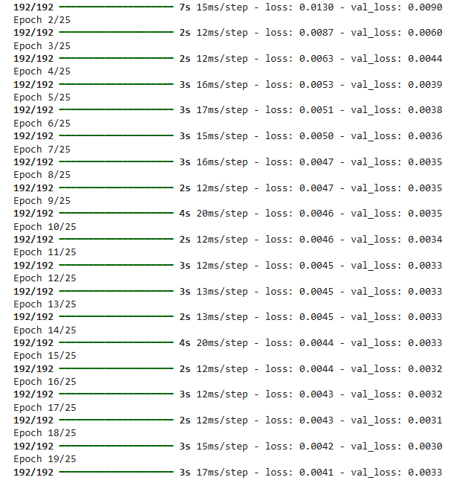
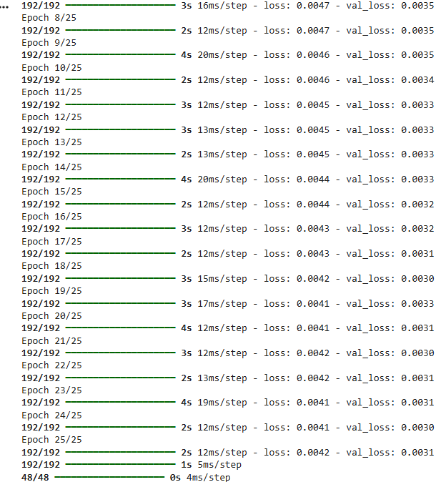

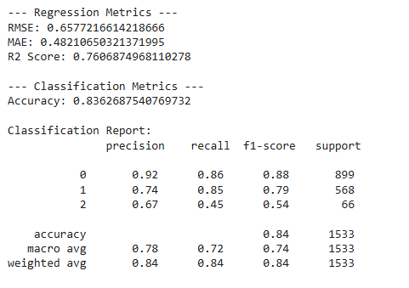
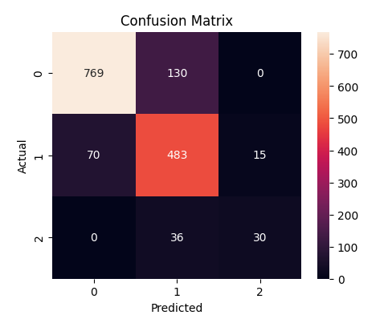
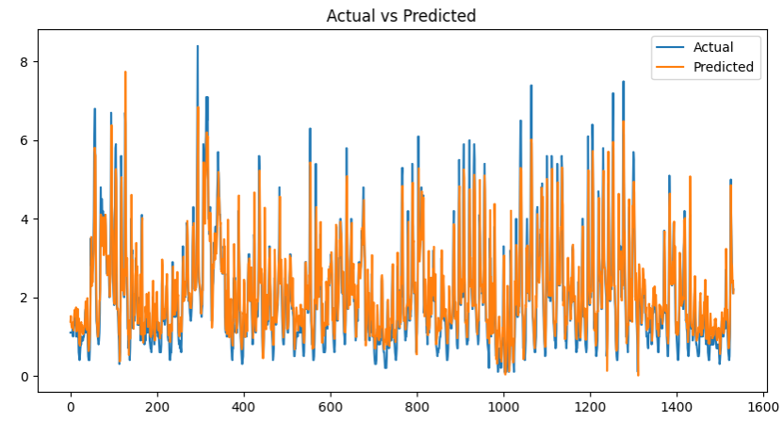
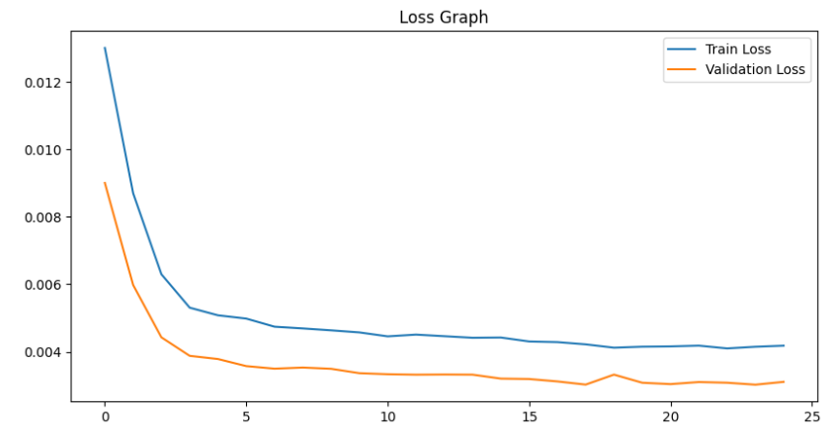

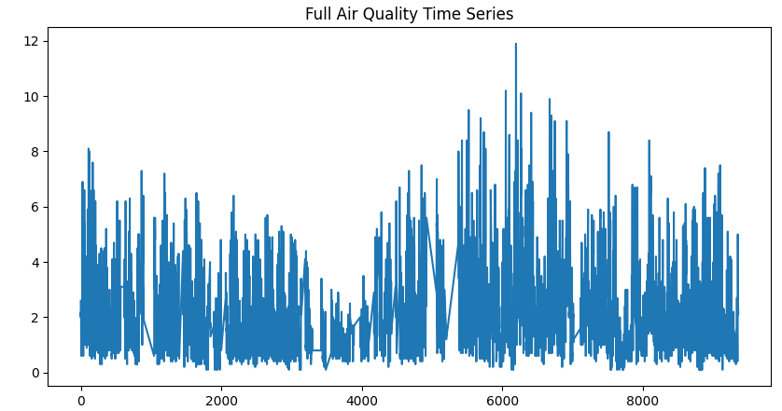

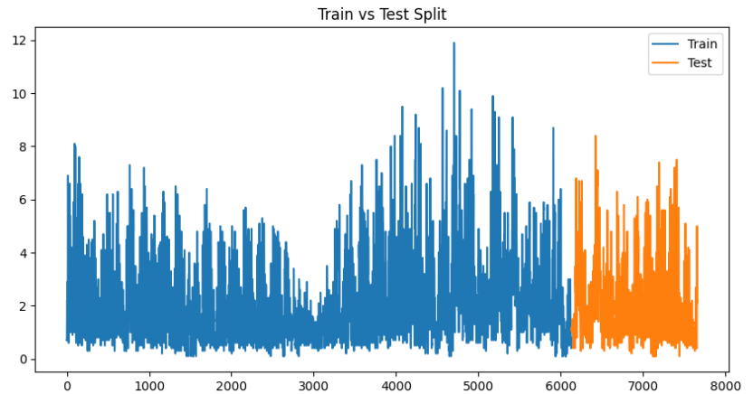

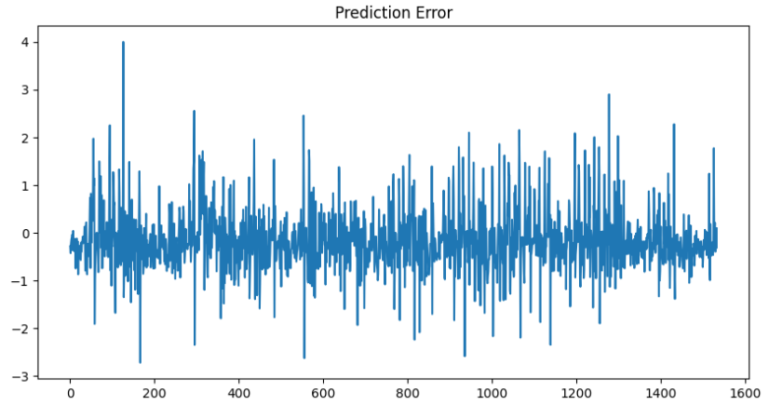

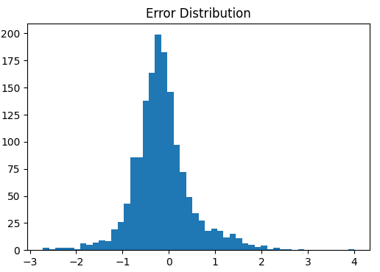

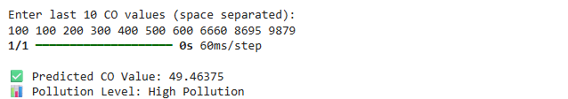

CONCLUSION
In this experiment, an LSTM-based neural network was implemented to perform time-series prediction on air quality data. The model successfully learned patterns from historical CO values and predicted future values with reasonable accuracy.
The preprocessing steps ensured that the dataset was clean and normalized, which contributed to stable training. The sequence generation process enabled the model to capture temporal dependencies effectively.
The model was evaluated using both regression and classification metrics, providing a comprehensive understanding of its performance. Visualization techniques further helped in analyzing trends, errors, and training behavior.
Overall, the experiment demonstrates the effectiveness of LSTM networks in handling time-series data and highlights their applicability in environmental monitoring and forecasting systems.

